Contact Us
Telephone: +1 646 809 7465
For general Enquiries: info@pinkribbon.org
For Donations contact: Donations@pinkribbon.org
For Affiliate information contact Affiliate@pinkribbon.org
Fo Collaborations contact: Collaborator@pinkribbon.org
For Partners and Corporate Partners contact: Partner@pinkribbon.org
For Grants and to discuss Scientific Research contact: Grants@ pinkribbon.org
Find us and follow us on
Instagram: @pinkribboninternational
Facebook: https://www.facebook.com/profile.php?id=61574173010505
Linkedin: https://www.linkedin.com/company/105950858
Quick Link Donate to Us
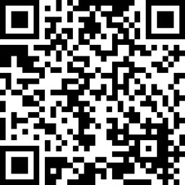
Email: info@pinkribbon.org
Tele/SMS: +1 646 809 7465
( +1 646 809 PINK)
PinkRibbon International PinkRibbon Inc
3000 Marcus Ave
Suite 1W5
New Hyde Park, NY
11042 -1007
New York, USA
Pink Ribbon, registered on 2008, is a public charity as defined by subparagraph (a)(5) of Section 102 (Definitions) of the Not-for-Profit Corporation Law. Pink Ribbon International is organized exclusively for charitable, educational and scientific purposes, within the meaning of Section 501(c)(3) of the Internal Revenue Code of 1986. Contributions are deductible under section 170 of the Code. Pink Ribbon is qualified to receive tax deductible bequests, devises, transfers and gifts under section 2055, 2106 and 2522 of the Code. Donations are tax deductible (EIN:
42-1766709 DLN: 700288004).

